# PUBLIC EXHIBITION

**Saturday, XX Month to Monday, XX Month YEAR**

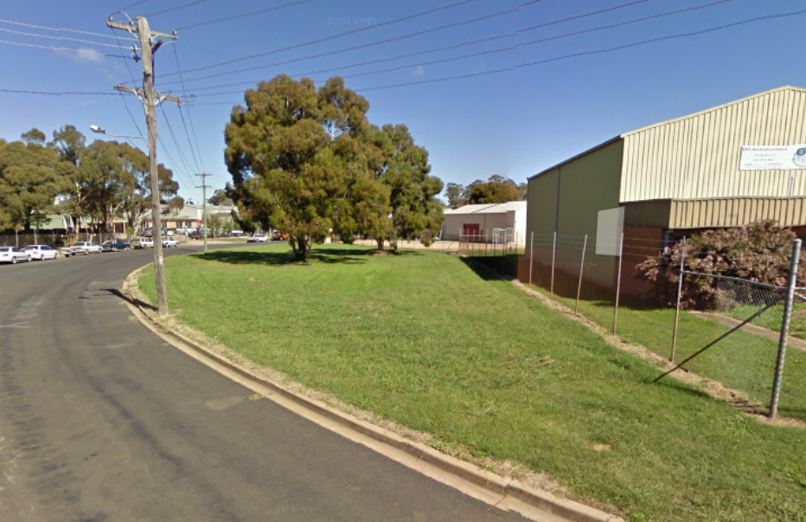

# Proposal to Amend Orange Local Environmental Plan 2011

# Amendment 10 (rezone 30 & 17 Leewood Drive)

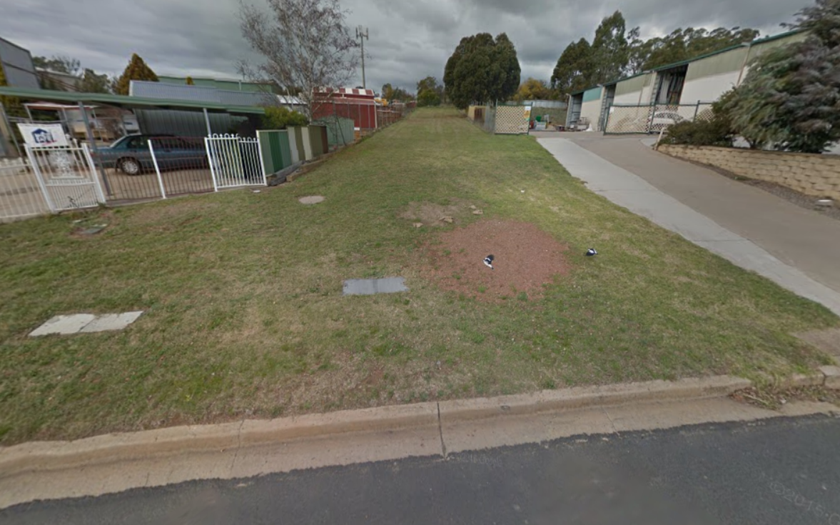 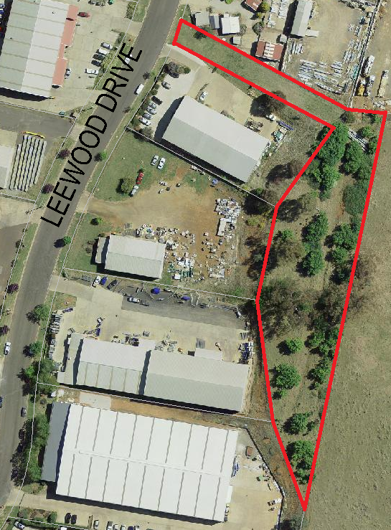

**WHAT IS ON EXHIBITION?**

Council is seeking to rezone 30 Leewood Drive, known as “Catto Park”, and 17 Leewood Drive, an unnamed reserve, from the RE1 Public Recreation to the IN1 General Industrial. Catto Park is located at the southern end of the Leewood Drive loop road in the Leewood Industrial estate.

**EXHIBITION MATERIALS**

The planning proposal is also comprised of the following supplemental documents:

|  |  |  |
| --- | --- | --- |
| Gateway Determination | Draft Land Zone Map |  |

**WHERE CAN I SEE IT?**

The exhibition materials can be inspected by any interested person during business hours at Orange City Council Civic Centre, ground floor, 135 Byng Street (Cnr of Lords Place), Orange. All materials are also available on Councils website [www.orange.nsw.gov.au](http://www.orange.nsw.gov.au) under the “Planning & Development” section.

**SUBMISSIONS**

Written comments on the draft amendments are welcome. All submissions received by Council will be considered before final decisions are made. Any submission received may be made publicly available and may include the name(s), address, signature and contact details provided.

All submissions are to be received by close of business **Monday XX Month YEAR.**

Submissions on the proposal can be sent to:

**General Manager**

**Orange City Council**

**P.O. Box 35**

**Orange NSW 2800**

**Attention: Craig Mortell – Senior Town Planner**

**Alternatively submissions may also be emailed to** [**Council@orange.nsw.gov.au**](mailto:Council@orange.nsw.gov.au)

**For further information please contact Council on (02) 6393 8000**

The following pages contain information required by the Department of Planning’s Guide to Preparing a Planning Proposal. The information is unavoidably technical, as it seeks to address a range of legislative requirements. Clarification may be sought from Councils planning staff during the exhibition period.

# Planning Proposal – Orange Local Environmental Plan 2011 – Amendment 10

## Introduction

The purpose of this document is to describe a planning proposal for an amendment of the Orange Local Environmental Plan 2011, to be known as amendment 10. The preparation of a planning proposal is the first step in preparing an LEP (or an amendment to an LEP).

Note: Throughout the course of preparing the proposed LEP, the planning proposal evolves. This is particularly the case for complex proposals in which the initial gateway determination will confirm the technical studies and consultation required to justify the proposal.

As the studies and consultation are undertaken, relevant parts of the planning proposal will be updated, amended and embellished. Therefore, particularly when viewed at an early stage, the level of detail in a planning proposal may appear to be limited in one or more respects.

This planning proposal has been prepared in accordance with the Department of Planning and Infrastructure’s document *A guide to preparing planning proposals* and is comprised of four parts;

**Part 1 Objectives and Intended Outcomes**

This part comprises a brief statement outlining the objectives and intended outcomes of the proposed amendment.

**Part 2 Explanation of the Provisions**

This part comprises a plain English explanation of the provisions and changes that are to be included in the amendment.

**Part 3 Justification**

This part establishes the justification for the objectives, outcomes and provisions and the process for their implementation.

**Part 4 Community Consultation**

This part details the level and methods of community consultation that is to be undertaken on the planning proposal.

**Part 5 Project Timeline**

This part consists of a table that sets out the key project milestones and anticipated commencement and completion dates for each milestone. The dates shown are indicative only and subject to review as the project progresses.

## Part 1 Objectives and Intended Outcomes

The objectives of this planning proposal are:

To amend the Land Zone Map so that 30 Leewood Drive, known as Catto Park, and 17 Leewood Drive, an unnamed reserve, is converted from RE1 Public Recreation land to IN1 General Industrial land to facilitate development of each site for industrial uses or for the provision of related car parking.

## Part 2 Explanation of the Provisions

|  |  |  |
| --- | --- | --- |
| **Item No.** | **Description** | **Proposed Change** |
| 1 | Plain English | Amendment of the Land Zone Map in accordance with the proposed Land Zone Map shown at attachment 1 |

## Part 3 Justification

### Section A – Need for the planning proposal

1. ***Is the planning proposal a result of any strategic study or report?***

Yes. The Blayney, Orange, Cabonne Rural and Industrial Subregional Strategy has, in relation to industry, the objective of providing adequate opportunities for employment-generating activities that will support the community and the economy of the Sub-Region. The strategic directions flowing from this objective include:

* (that industry) will be protected from encroachment by activities that could hinder their effective operation,
* (that new industrial land) are located near existing zoned industrial land.

The proposed rezoning involves a small amount of recreation zoned land contained within an established industrial estate. Rezoning would enable the site to be developed for car parking which would improve the functional operation of the estate by reducing the potential conflict between light and heavy vehicles.

1. ***Is the planning proposal the best means of achieving the objectives or intended outcomes, or is there a better way?***

The planning proposal is the best known means of achieving the intended outcomes. Both sites are directly accessible from Leewood Drive and contiguous with existing industrial land, as such the proposal will enhance the industrial performance of the estate without encroaching upon other non-industrial lands.

1. ***Is there a net community benefit?***

Yes. The result of the planning proposal will provide additional area for industrial purposes and greater parking in the estate, allowing greater segregation of light and heavy vehicles. The additional potential parking would also enable a commensurate expansion of industrial capacity resulting in increased support for employment opportunities in the local economy.

### Section B – Relationship to strategic planning framework

1. ***Is the planning proposal consistent with the objectives and actions contained within the applicable regional or sub-regional strategy?***

Yes. The Blayney, Orange, Cabonne Subregional Rural and Industrial Land Use Strategy details the need to identify and provide additional industrial land. The strategy encourages the provision of industrial land in close proximity to existing industrial estates.

1. ***Is the planning proposal consistent with the local council’s Community Strategic Plan, or other local strategic plan?***

Yes. The Orange Community Strategic Plan seeks to promote the local economy across a broad mix of sectors including industrial activities.

1. ***Is the planning proposal consistent with applicable state environmental planning policies?***

Yes.

1. ***Is the planning proposal consistent with applicable Ministerial Directions (s.117 directions)?***

Yes. Direction 1.1 seeks to:

* Encourage employment growth in suitable locations
* Protect employment land in business and industrial zones, and
* Support the viability of identified strategic centres.

The direction requires that Council must give effect to the above objectives by retaining the areas and locations of existing business and industrial zones, not reduce the total potential floor space area cfor employment uses and related public services in business zones, not reduce the total potential floor space area for industrial uses in industrial zones, and ensure that proposed new employment areas are in accordance with a strategy that is approved by the Director General of the Department of Planning.

In this regard rezoning of Catto Park and the unnamed reserve at 17 Leewood Drive within the Leewood Industrial estate is considered to be entirely consistent with the objectives and requirements described above.

### Section C – Environmental, social and economic impact

1. ***Is there any likelihood that critical habitat or threatened species, populations or ecological communities, or their habitats, will be adversely affected as a result of the proposal?***

No. The site selected for rezoning has been examined and is not considered to provide critical habitat and no threatened species, populations or ecological communities or their habitats are evident on the site.

1. ***Are there any other likely environmental effects as a result of the planning proposal and how are they proposed to be managed?***

None envisaged.

1. ***How has the planning proposal adequately addressed any social and economic effects?***

Yes. The principal economic effects would be to facilitate additional industrial development which is likely to marginally increase employment opportunities. Additionally the rezoning and subsequent sale or development would remove a maintenance cost on Council and funds obtained from the sale of the site would further improve Councils budget position.

The social effects of the rezoning and subsequent development are that the site would no longer be available for passive recreation. Given that the site is located within an industrial estate and that the estate has alternative passive recreation lands (on the Elsham Avenue frontage) the site is considered to be surplus to requirements.

### Section D – State and Commonwealth interests

1. ***Is there adequate public infrastructure for the planning proposal?***

Yes. The site is already fully serviced and rezoning will not require additional public infrastructure provision.

1. ***What are the views of State and Commonwealth public authorities consulted in accordance with the gateway determination?***

Not applicable, the planning proposal is at the pre-gateway stage.

## Part 4 Community Consultation

Community consultation will be undertaken in accordance with the requirements of the gateway determination. It is anticipated that this proposal will not be deemed to be a low impact proposal. Accordingly an exhibition period of 28 days is expected.

This will commence by giving notice of the public exhibition of the planning proposal via:

* an advertisement in the Central Western Daily;
* a notification on the Orange City Council website [www.orange.nsw.gov.au](http://www.orange.nsw.gov.au); and
* written advice direct to adjoining landowners.

All forms of the notice shall include:

* a brief description of the objectives and intended outcomes of the planning proposal;
* an indication of the land affected by the planning proposal;
* the location and dates where the planning proposal may be inspected;
* the contact name and address at Orange City Council where submissions may be directed; and
* the closing date of the submission process.

During the exhibition period, the following materials will be made freely available for public inspection:

* The planning proposal, in the form approved for community consultation by the Director-General of Planning;
* The gateway determination; and
* All studies and supporting material relied upon by the planning proposal.

Following the exhibition period, a report will be prepared analysing any submissions received and making recommendations as to any appropriate changes or adjustments to the planning proposal, for the consideration of Orange City Council.

Where contact details have been provided all persons and organisations making a submission will be advised of the date and time of the relevant council (or committee) meeting where the report is to be considered, and subsequently advised of the determination.

## Part 5 Project Timeline

The following table provides an overview of the intended project timeline for this Planning Proposal.

|  |  |  |
| --- | --- | --- |
| **Project stage** | **Commencement** | **Completion** |
| Gateway Determination | Late August 2015 | Early September 2015 |
| Government Agency consultation | September 2015 | October 2015 |
| Public Exhibition Period | September 2015 | October 2015 |
| Public Hearing | Not anticipated | |
| Consideration of Submissions | Late October 2015 | Early November 2015 |
| Consideration of post exhibition proposals  (Report to Council) | November 2015 | |
| Seeking and obtaining legal opinion from Parliamentary Counsels Office | Mid November 2015 | Late November 2015 |
| Submission to the Department of Planning and Infrastructure to finalise | Dependent on PCO | |
| Anticipated date the plan will be forwarded to the Department for notification | Dependent on PCO | |